[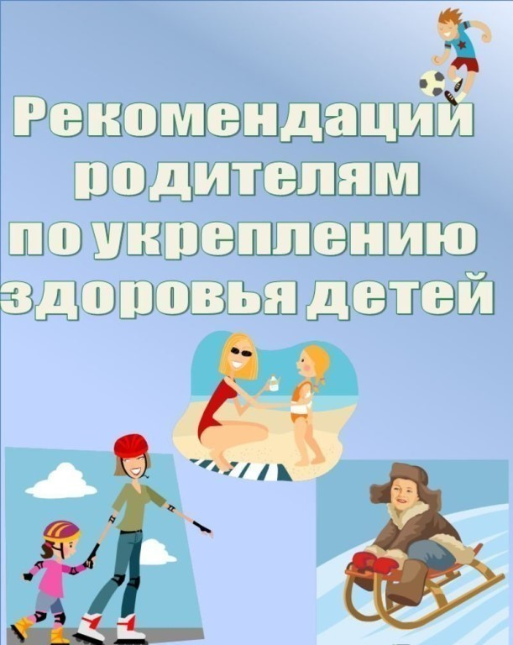](https://ok.ru/dk?cmd=PopLayerPhoto&st.layer.cmd=PopLayerPhotoOuter&st.layer.type=GROUP&st.layer.revNav=off&st.layer.limitedUi=false&st.layer.closeLayers=off&st.layer.sphotoIds=886473245492;886473245748;886473246004;886473246260;886473246516;886473246772;886473247028&st.layer.showNav=on&st.layer.photoAlbumId=57249062780980&st.layer.epm=off&st.layer.photoId=886473245492&st.layer.opl=off&st.layer.navStartPhotoId=886473245492&st.layer.sbd=off&st.cmd=userMain&st._aid=GroupTopicLayer_openPhotoLayer)

[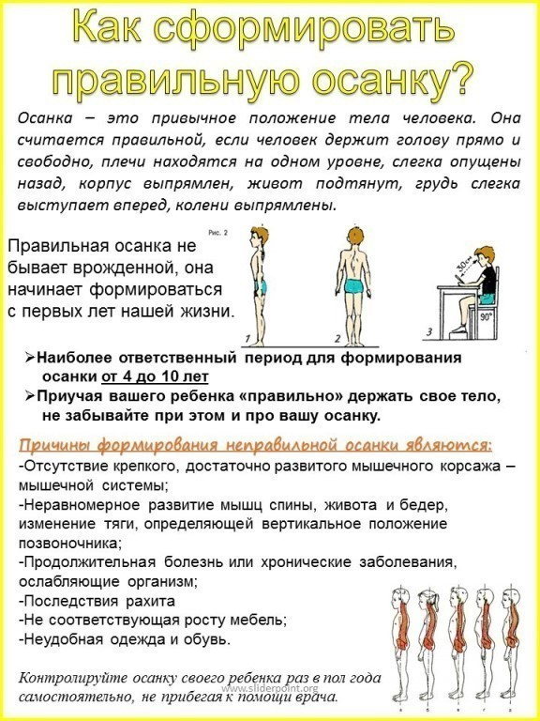](https://ok.ru/dk?cmd=PopLayerPhoto&st.layer.cmd=PopLayerPhotoOuter&st.layer.type=GROUP&st.layer.revNav=off&st.layer.limitedUi=false&st.layer.closeLayers=off&st.layer.sphotoIds=886473245492;886473245748;886473246004;886473246260;886473246516;886473246772;886473247028&st.layer.showNav=on&st.layer.photoAlbumId=57249062780980&st.layer.epm=off&st.layer.photoId=886473245748&st.layer.opl=off&st.layer.navStartPhotoId=886473245748&st.layer.sbd=off&st.cmd=userMain&st._aid=GroupTopicLayer_openPhotoLayer)

[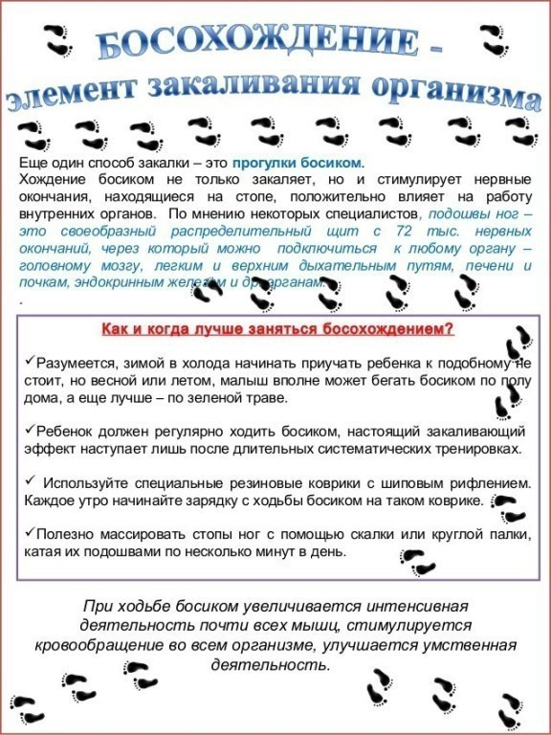](https://ok.ru/dk?cmd=PopLayerPhoto&st.layer.cmd=PopLayerPhotoOuter&st.layer.type=GROUP&st.layer.revNav=off&st.layer.limitedUi=false&st.layer.closeLayers=off&st.layer.sphotoIds=886473245492;886473245748;886473246004;886473246260;886473246516;886473246772;886473247028&st.layer.showNav=on&st.layer.photoAlbumId=57249062780980&st.layer.epm=off&st.layer.photoId=886473246004&st.layer.opl=off&st.layer.navStartPhotoId=886473246004&st.layer.sbd=off&st.cmd=userMain&st._aid=GroupTopicLayer_openPhotoLayer)

[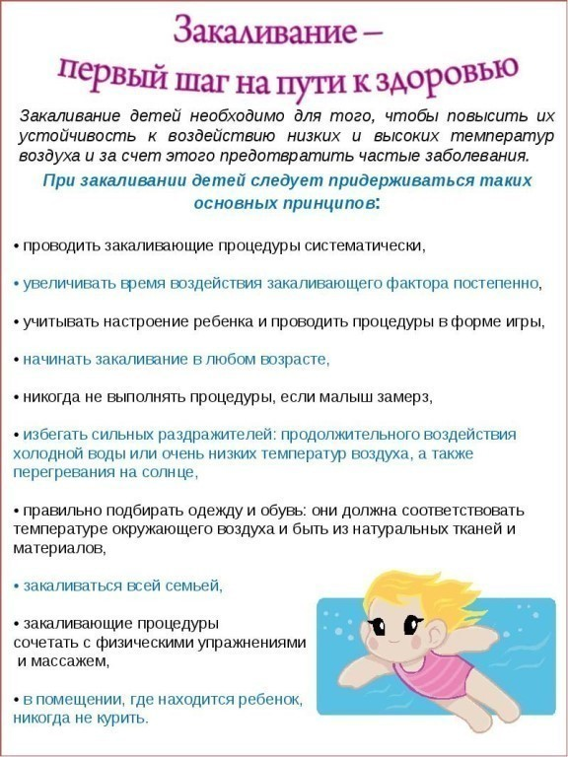](https://ok.ru/dk?cmd=PopLayerPhoto&st.layer.cmd=PopLayerPhotoOuter&st.layer.type=GROUP&st.layer.revNav=off&st.layer.limitedUi=false&st.layer.closeLayers=off&st.layer.sphotoIds=886473245492;886473245748;886473246004;886473246260;886473246516;886473246772;886473247028&st.layer.showNav=on&st.layer.photoAlbumId=57249062780980&st.layer.epm=off&st.layer.photoId=886473246260&st.layer.opl=off&st.layer.navStartPhotoId=886473246260&st.layer.sbd=off&st.cmd=userMain&st._aid=GroupTopicLayer_openPhotoLayer)

[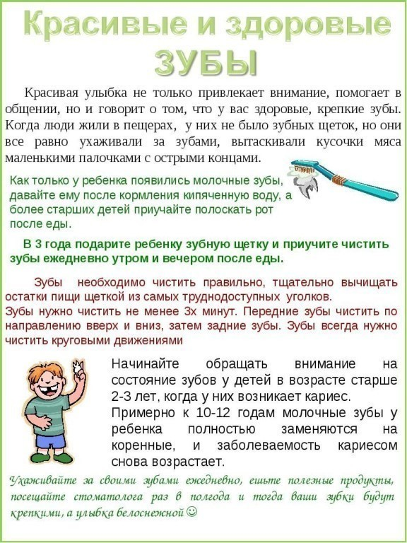](https://ok.ru/dk?cmd=PopLayerPhoto&st.layer.cmd=PopLayerPhotoOuter&st.layer.type=GROUP&st.layer.revNav=off&st.layer.limitedUi=false&st.layer.closeLayers=off&st.layer.sphotoIds=886473245492;886473245748;886473246004;886473246260;886473246516;886473246772;886473247028&st.layer.showNav=on&st.layer.photoAlbumId=57249062780980&st.layer.epm=off&st.layer.photoId=886473246516&st.layer.opl=off&st.layer.navStartPhotoId=886473246516&st.layer.sbd=off&st.cmd=userMain&st._aid=GroupTopicLayer_openPhotoLayer)

[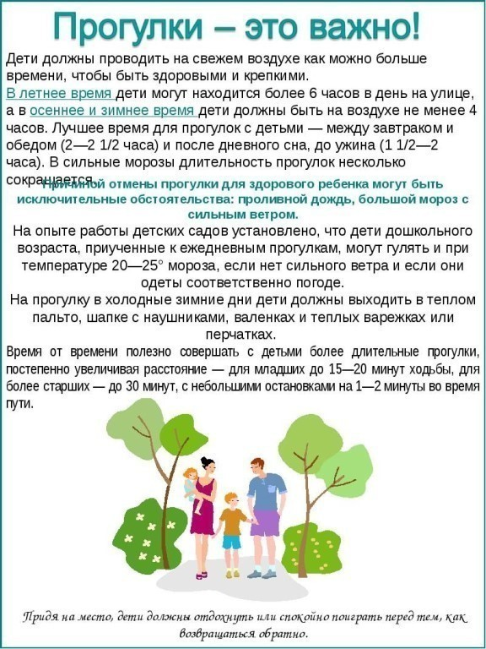](https://ok.ru/dk?cmd=PopLayerPhoto&st.layer.cmd=PopLayerPhotoOuter&st.layer.type=GROUP&st.layer.revNav=off&st.layer.limitedUi=false&st.layer.closeLayers=off&st.layer.sphotoIds=886473245492;886473245748;886473246004;886473246260;886473246516;886473246772;886473247028&st.layer.showNav=on&st.layer.photoAlbumId=57249062780980&st.layer.epm=off&st.layer.photoId=886473246772&st.layer.opl=off&st.layer.navStartPhotoId=886473246772&st.layer.sbd=off&st.cmd=userMain&st._aid=GroupTopicLayer_openPhotoLayer)

[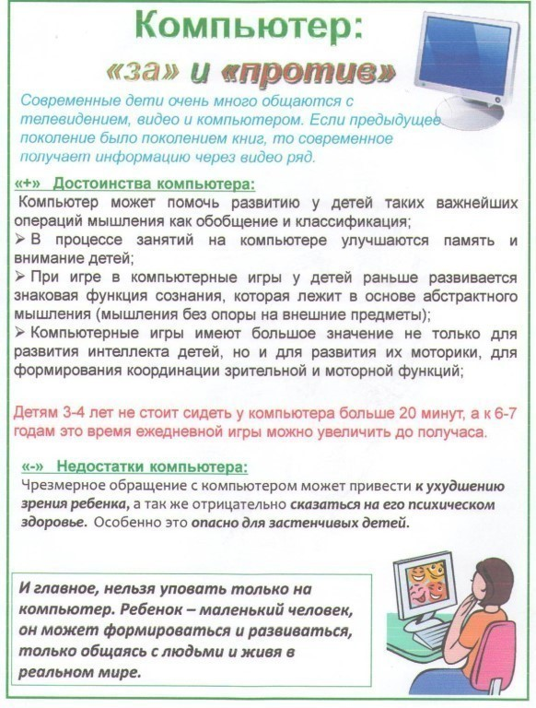](https://ok.ru/dk?cmd=PopLayerPhoto&st.layer.cmd=PopLayerPhotoOuter&st.layer.type=GROUP&st.layer.revNav=off&st.layer.limitedUi=false&st.layer.closeLayers=off&st.layer.sphotoIds=886473245492;886473245748;886473246004;886473246260;886473246516;886473246772;886473247028&st.layer.showNav=on&st.layer.photoAlbumId=57249062780980&st.layer.epm=off&st.layer.photoId=886473247028&st.layer.opl=off&st.layer.navStartPhotoId=886473247028&st.layer.sbd=off&st.cmd=userMain&st._aid=GroupTopicLayer_openPhotoLayer)