[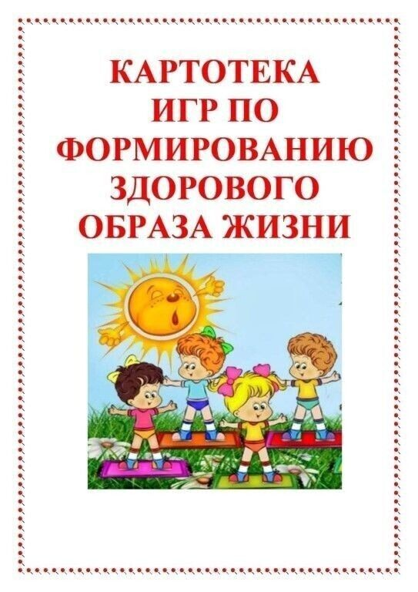](https://ok.ru/dk?cmd=PopLayerNewPhotoWrapper&st.layer.cmd=PopLayerNewPhotoOuter&st.layer.plc=mediaTopic&st.layer.photoId=936767428404&st.layer.type=GROUP&st.layer.sphotoIds=936767428404%3B936767428660%3B936767428916%3B936767429172%3B936767429684%3B936767429940%3B936767430196%3B936767430452&st.cmd=userMain&st._aid=GroupTopicLayer_openPhotoLayer)

[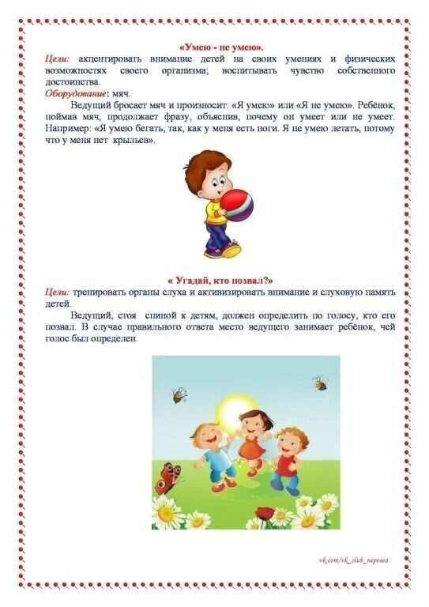](https://ok.ru/dk?cmd=PopLayerNewPhotoWrapper&st.layer.cmd=PopLayerNewPhotoOuter&st.layer.plc=mediaTopic&st.layer.photoId=936767428660&st.layer.type=GROUP&st.layer.sphotoIds=936767428404%3B936767428660%3B936767428916%3B936767429172%3B936767429684%3B936767429940%3B936767430196%3B936767430452&st.cmd=userMain&st._aid=GroupTopicLayer_openPhotoLayer)

[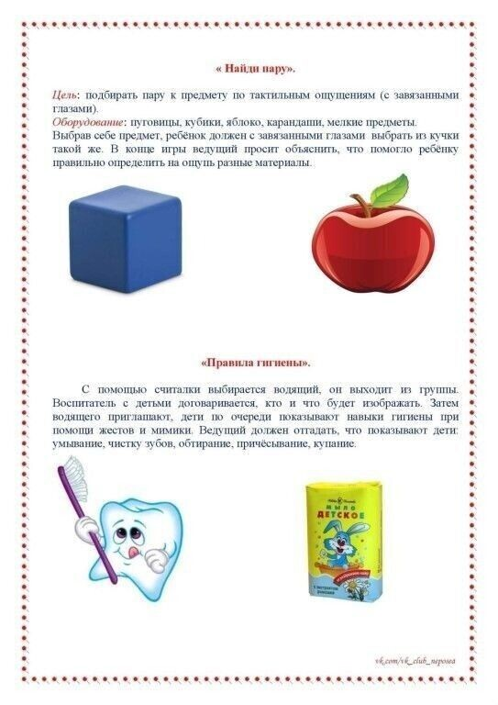](https://ok.ru/dk?cmd=PopLayerNewPhotoWrapper&st.layer.cmd=PopLayerNewPhotoOuter&st.layer.plc=mediaTopic&st.layer.photoId=936767428916&st.layer.type=GROUP&st.layer.sphotoIds=936767428404%3B936767428660%3B936767428916%3B936767429172%3B936767429684%3B936767429940%3B936767430196%3B936767430452&st.cmd=userMain&st._aid=GroupTopicLayer_openPhotoLayer)

[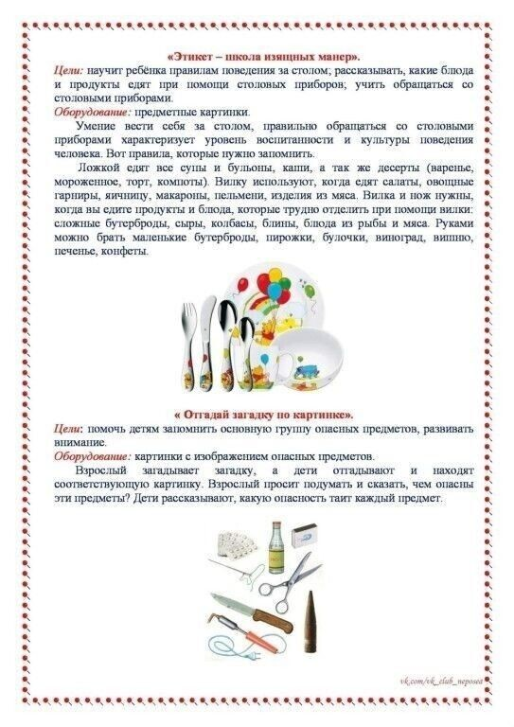](https://ok.ru/dk?cmd=PopLayerNewPhotoWrapper&st.layer.cmd=PopLayerNewPhotoOuter&st.layer.plc=mediaTopic&st.layer.photoId=936767429172&st.layer.type=GROUP&st.layer.sphotoIds=936767428404%3B936767428660%3B936767428916%3B936767429172%3B936767429684%3B936767429940%3B936767430196%3B936767430452&st.cmd=userMain&st._aid=GroupTopicLayer_openPhotoLayer)

[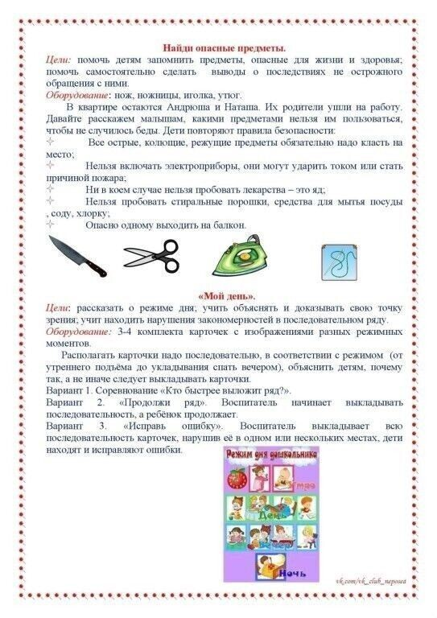](https://ok.ru/dk?cmd=PopLayerNewPhotoWrapper&st.layer.cmd=PopLayerNewPhotoOuter&st.layer.plc=mediaTopic&st.layer.photoId=936767429684&st.layer.type=GROUP&st.layer.sphotoIds=936767428404%3B936767428660%3B936767428916%3B936767429172%3B936767429684%3B936767429940%3B936767430196%3B936767430452&st.cmd=userMain&st._aid=GroupTopicLayer_openPhotoLayer)

[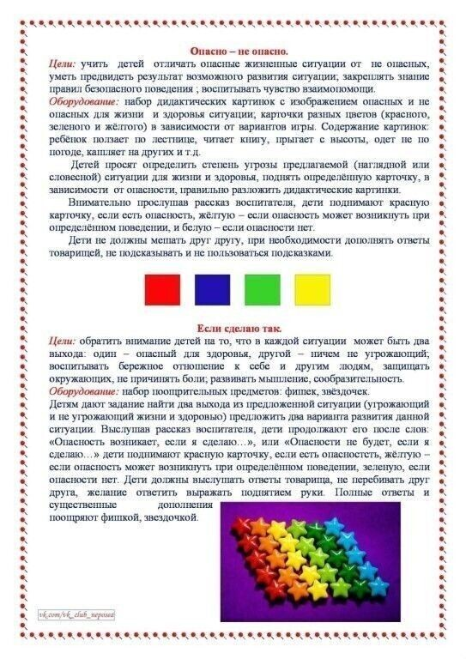](https://ok.ru/dk?cmd=PopLayerNewPhotoWrapper&st.layer.cmd=PopLayerNewPhotoOuter&st.layer.plc=mediaTopic&st.layer.photoId=936767429940&st.layer.type=GROUP&st.layer.sphotoIds=936767428404%3B936767428660%3B936767428916%3B936767429172%3B936767429684%3B936767429940%3B936767430196%3B936767430452&st.cmd=userMain&st._aid=GroupTopicLayer_openPhotoLayer)

[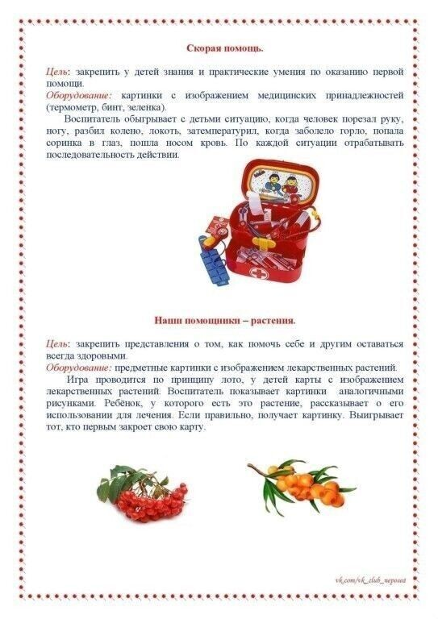](https://ok.ru/dk?cmd=PopLayerNewPhotoWrapper&st.layer.cmd=PopLayerNewPhotoOuter&st.layer.plc=mediaTopic&st.layer.photoId=936767430196&st.layer.type=GROUP&st.layer.sphotoIds=936767428404%3B936767428660%3B936767428916%3B936767429172%3B936767429684%3B936767429940%3B936767430196%3B936767430452&st.cmd=userMain&st._aid=GroupTopicLayer_openPhotoLayer)

[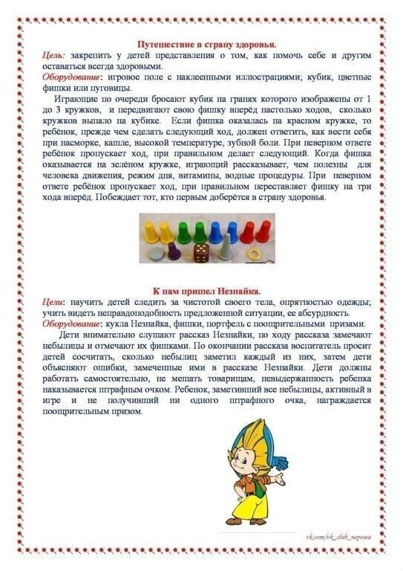](https://ok.ru/dk?cmd=PopLayerNewPhotoWrapper&st.layer.cmd=PopLayerNewPhotoOuter&st.layer.plc=mediaTopic&st.layer.photoId=936767430452&st.layer.type=GROUP&st.layer.sphotoIds=936767428404%3B936767428660%3B936767428916%3B936767429172%3B936767429684%3B936767429940%3B936767430196%3B936767430452&st.cmd=userMain&st._aid=GroupTopicLayer_openPhotoLayer)