[](https://ok.ru/dk?cmd=PopLayerPhoto&st.layer.cmd=PopLayerPhotoOuter&st.layer.type=GROUP&st.layer.revNav=off&st.layer.limitedUi=false&st.layer.closeLayers=off&st.layer.sphotoIds=872274822496%3B872274827872%3B872274827360%3B872274827104%3B872274826848%3B872274826592%3B872274826336%3B872274826080%3B872274825824%3B872274825568%3B872274825312%3B872274825056%3B872274824800&st.layer.showNav=on&st.layer.photoAlbumId=53612444975200&st.layer.epm=off&st.layer.photoId=872274822496&st.layer.opl=off&st.layer.navStartPhotoId=872274822496&st.layer.sbd=off&st.cmd=userMain&st._aid=GroupTopicLayer_openPhotoLayer)

[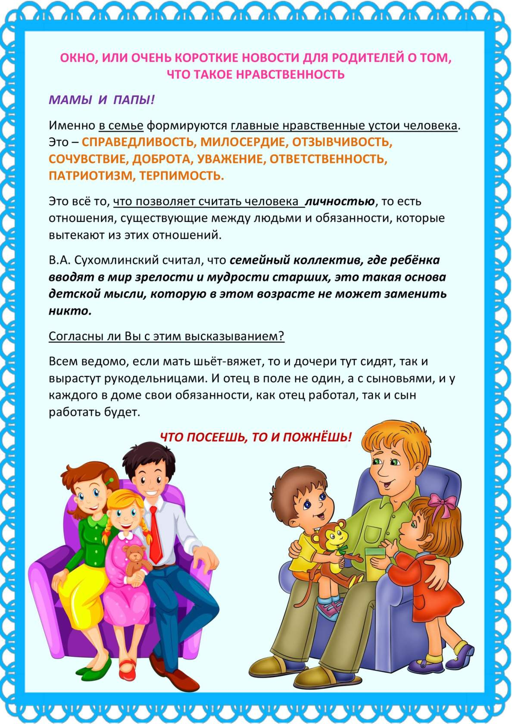](https://ok.ru/dk?cmd=PopLayerPhoto&st.layer.cmd=PopLayerPhotoOuter&st.layer.type=GROUP&st.layer.revNav=off&st.layer.limitedUi=false&st.layer.closeLayers=off&st.layer.sphotoIds=872274822496%3B872274827872%3B872274827360%3B872274827104%3B872274826848%3B872274826592%3B872274826336%3B872274826080%3B872274825824%3B872274825568%3B872274825312%3B872274825056%3B872274824800&st.layer.showNav=on&st.layer.photoAlbumId=53612444975200&st.layer.epm=off&st.layer.photoId=872274827872&st.layer.opl=off&st.layer.navStartPhotoId=872274827872&st.layer.sbd=off&st.cmd=userMain&st._aid=GroupTopicLayer_openPhotoLayer)

[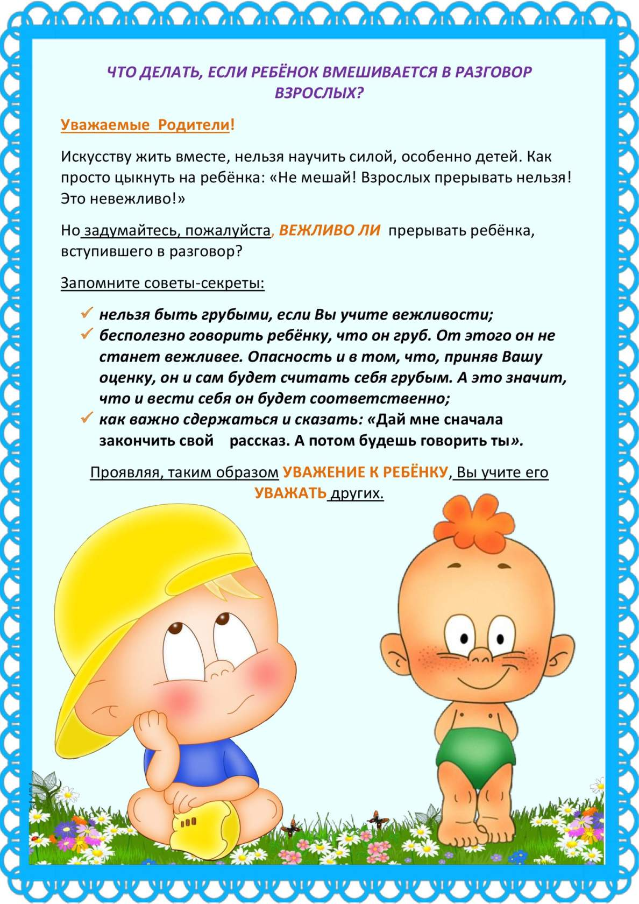](https://ok.ru/dk?cmd=PopLayerPhoto&st.layer.cmd=PopLayerPhotoOuter&st.layer.type=GROUP&st.layer.revNav=off&st.layer.limitedUi=false&st.layer.closeLayers=off&st.layer.sphotoIds=872274822496%3B872274827872%3B872274827360%3B872274827104%3B872274826848%3B872274826592%3B872274826336%3B872274826080%3B872274825824%3B872274825568%3B872274825312%3B872274825056%3B872274824800&st.layer.showNav=on&st.layer.photoAlbumId=53612444975200&st.layer.epm=off&st.layer.photoId=872274827360&st.layer.opl=off&st.layer.navStartPhotoId=872274827360&st.layer.sbd=off&st.cmd=userMain&st._aid=GroupTopicLayer_openPhotoLayer)

[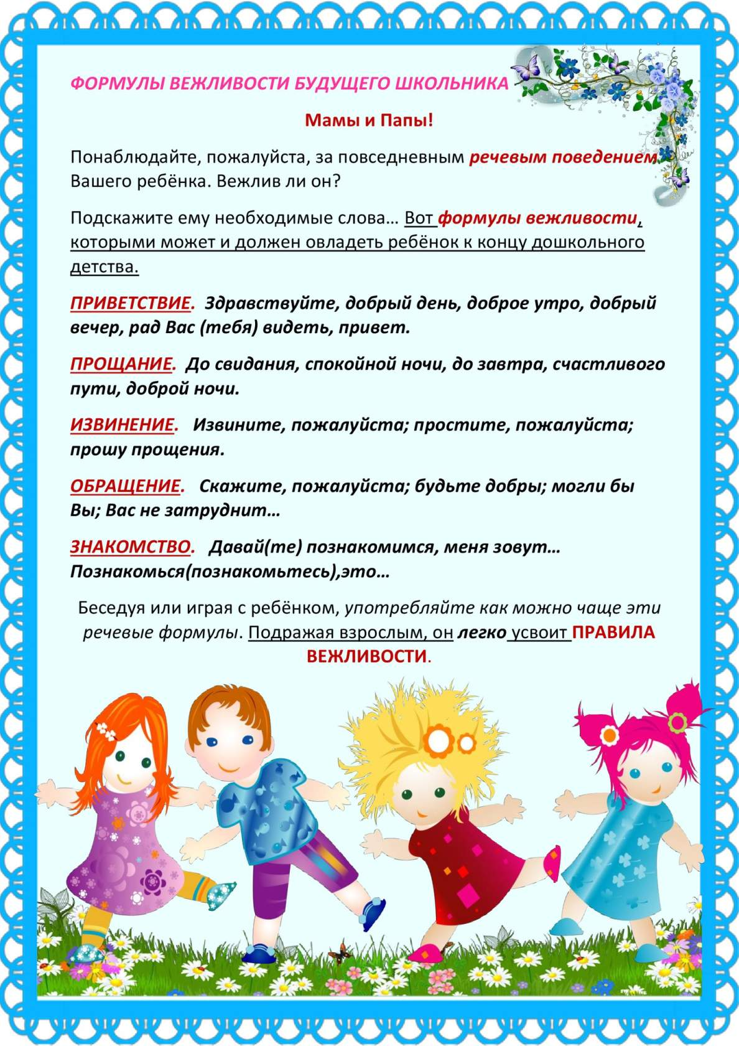](https://ok.ru/dk?cmd=PopLayerPhoto&st.layer.cmd=PopLayerPhotoOuter&st.layer.type=GROUP&st.layer.revNav=off&st.layer.limitedUi=false&st.layer.closeLayers=off&st.layer.sphotoIds=872274822496%3B872274827872%3B872274827360%3B872274827104%3B872274826848%3B872274826592%3B872274826336%3B872274826080%3B872274825824%3B872274825568%3B872274825312%3B872274825056%3B872274824800&st.layer.showNav=on&st.layer.photoAlbumId=53612444975200&st.layer.epm=off&st.layer.photoId=872274827104&st.layer.opl=off&st.layer.navStartPhotoId=872274827104&st.layer.sbd=off&st.cmd=userMain&st._aid=GroupTopicLayer_openPhotoLayer)

[](https://ok.ru/dk?cmd=PopLayerPhoto&st.layer.cmd=PopLayerPhotoOuter&st.layer.type=GROUP&st.layer.revNav=off&st.layer.limitedUi=false&st.layer.closeLayers=off&st.layer.sphotoIds=872274822496%3B872274827872%3B872274827360%3B872274827104%3B872274826848%3B872274826592%3B872274826336%3B872274826080%3B872274825824%3B872274825568%3B872274825312%3B872274825056%3B872274824800&st.layer.showNav=on&st.layer.photoAlbumId=53612444975200&st.layer.epm=off&st.layer.photoId=872274826848&st.layer.opl=off&st.layer.navStartPhotoId=872274826848&st.layer.sbd=off&st.cmd=userMain&st._aid=GroupTopicLayer_openPhotoLayer)

[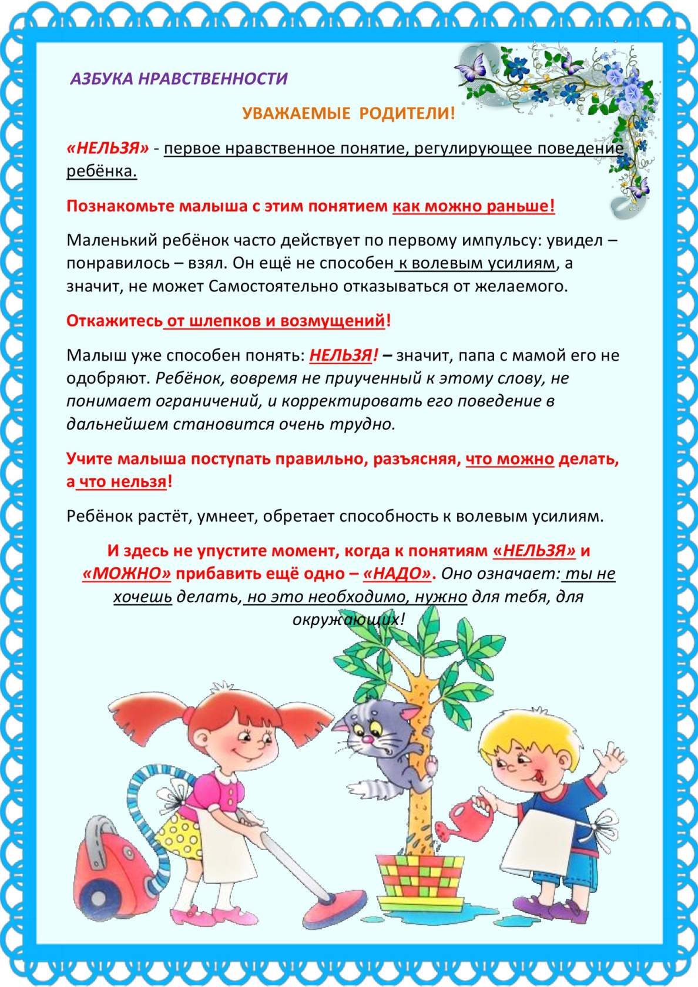](https://ok.ru/dk?cmd=PopLayerPhoto&st.layer.cmd=PopLayerPhotoOuter&st.layer.type=GROUP&st.layer.revNav=off&st.layer.limitedUi=false&st.layer.closeLayers=off&st.layer.sphotoIds=872274822496%3B872274827872%3B872274827360%3B872274827104%3B872274826848%3B872274826592%3B872274826336%3B872274826080%3B872274825824%3B872274825568%3B872274825312%3B872274825056%3B872274824800&st.layer.showNav=on&st.layer.photoAlbumId=53612444975200&st.layer.epm=off&st.layer.photoId=872274826592&st.layer.opl=off&st.layer.navStartPhotoId=872274826592&st.layer.sbd=off&st.cmd=userMain&st._aid=GroupTopicLayer_openPhotoLayer)

[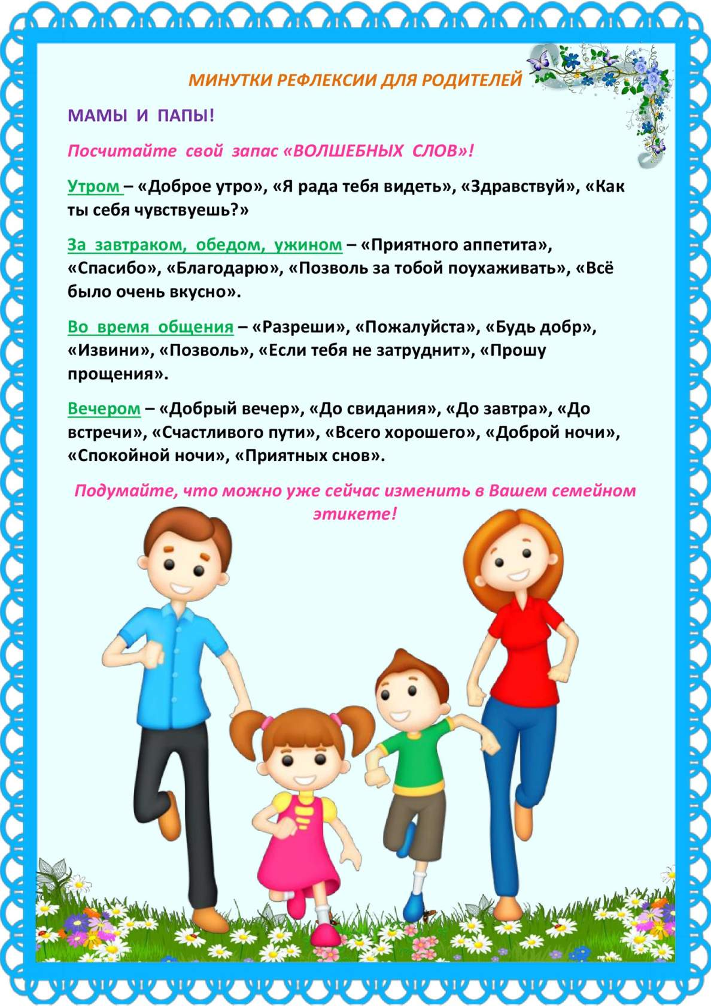](https://ok.ru/dk?cmd=PopLayerPhoto&st.layer.cmd=PopLayerPhotoOuter&st.layer.type=GROUP&st.layer.revNav=off&st.layer.limitedUi=false&st.layer.closeLayers=off&st.layer.sphotoIds=872274822496%3B872274827872%3B872274827360%3B872274827104%3B872274826848%3B872274826592%3B872274826336%3B872274826080%3B872274825824%3B872274825568%3B872274825312%3B872274825056%3B872274824800&st.layer.showNav=on&st.layer.photoAlbumId=53612444975200&st.layer.epm=off&st.layer.photoId=872274826336&st.layer.opl=off&st.layer.navStartPhotoId=872274826336&st.layer.sbd=off&st.cmd=userMain&st._aid=GroupTopicLayer_openPhotoLayer)

[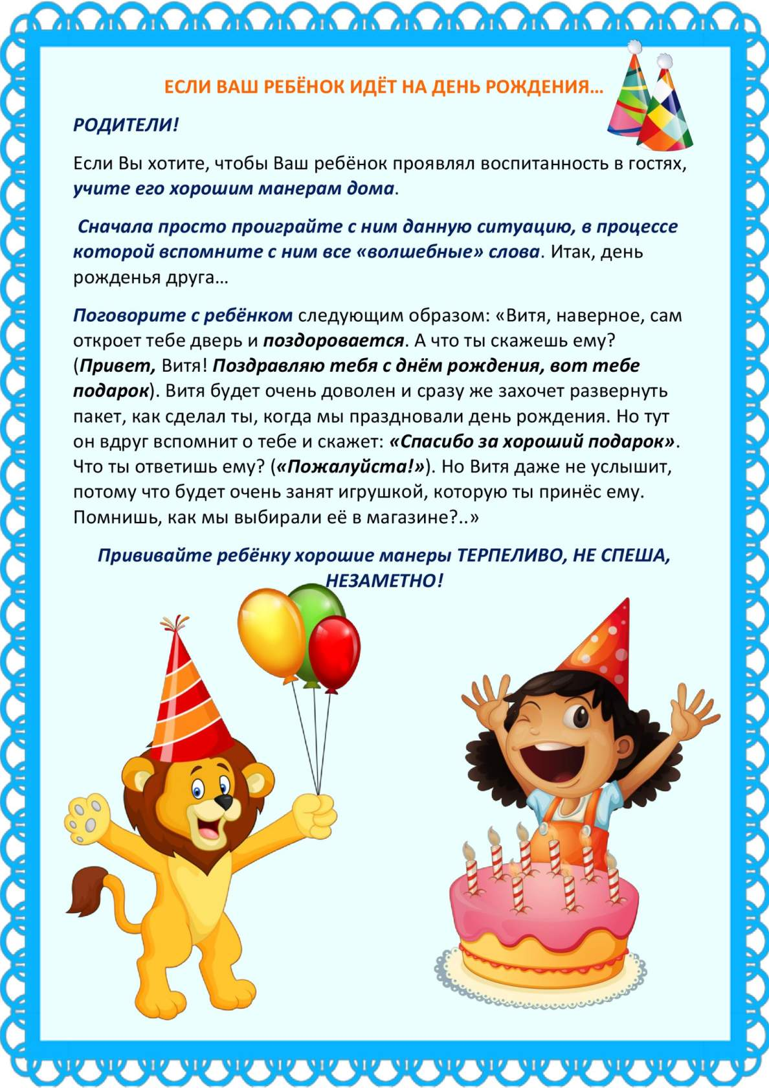](https://ok.ru/dk?cmd=PopLayerPhoto&st.layer.cmd=PopLayerPhotoOuter&st.layer.type=GROUP&st.layer.revNav=off&st.layer.limitedUi=false&st.layer.closeLayers=off&st.layer.sphotoIds=872274822496%3B872274827872%3B872274827360%3B872274827104%3B872274826848%3B872274826592%3B872274826336%3B872274826080%3B872274825824%3B872274825568%3B872274825312%3B872274825056%3B872274824800&st.layer.showNav=on&st.layer.photoAlbumId=53612444975200&st.layer.epm=off&st.layer.photoId=872274826080&st.layer.opl=off&st.layer.navStartPhotoId=872274826080&st.layer.sbd=off&st.cmd=userMain&st._aid=GroupTopicLayer_openPhotoLayer)

[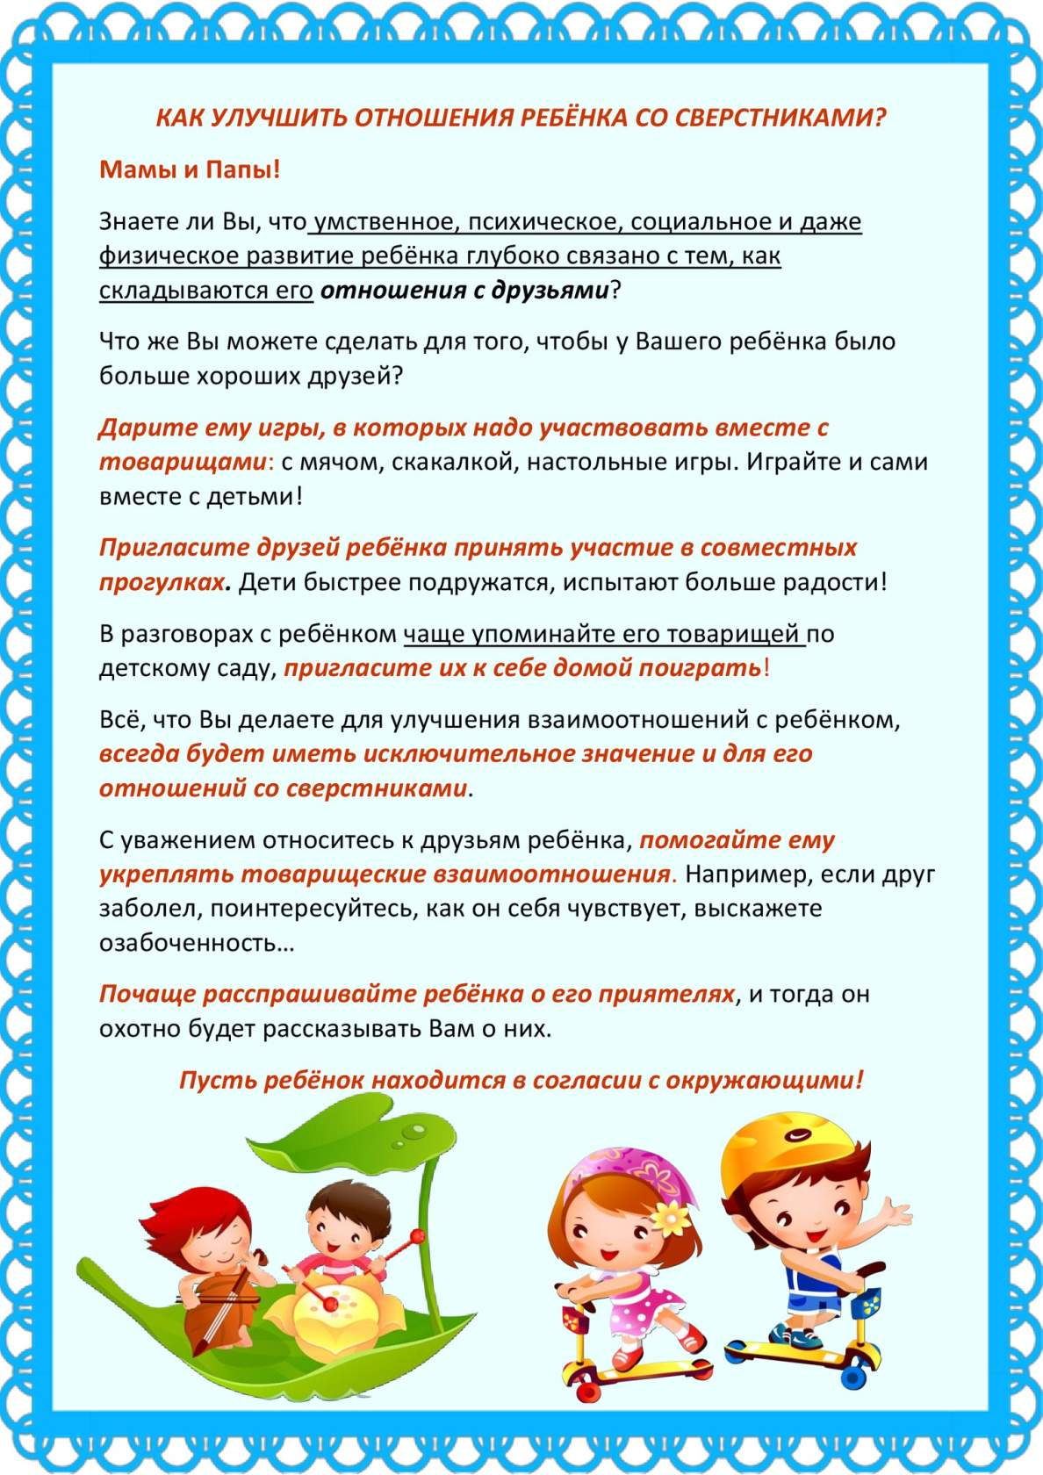](https://ok.ru/dk?cmd=PopLayerPhoto&st.layer.cmd=PopLayerPhotoOuter&st.layer.type=GROUP&st.layer.revNav=off&st.layer.limitedUi=false&st.layer.closeLayers=off&st.layer.sphotoIds=872274822496%3B872274827872%3B872274827360%3B872274827104%3B872274826848%3B872274826592%3B872274826336%3B872274826080%3B872274825824%3B872274825568%3B872274825312%3B872274825056%3B872274824800&st.layer.showNav=on&st.layer.photoAlbumId=53612444975200&st.layer.epm=off&st.layer.photoId=872274825824&st.layer.opl=off&st.layer.navStartPhotoId=872274825824&st.layer.sbd=off&st.cmd=userMain&st._aid=GroupTopicLayer_openPhotoLayer)

[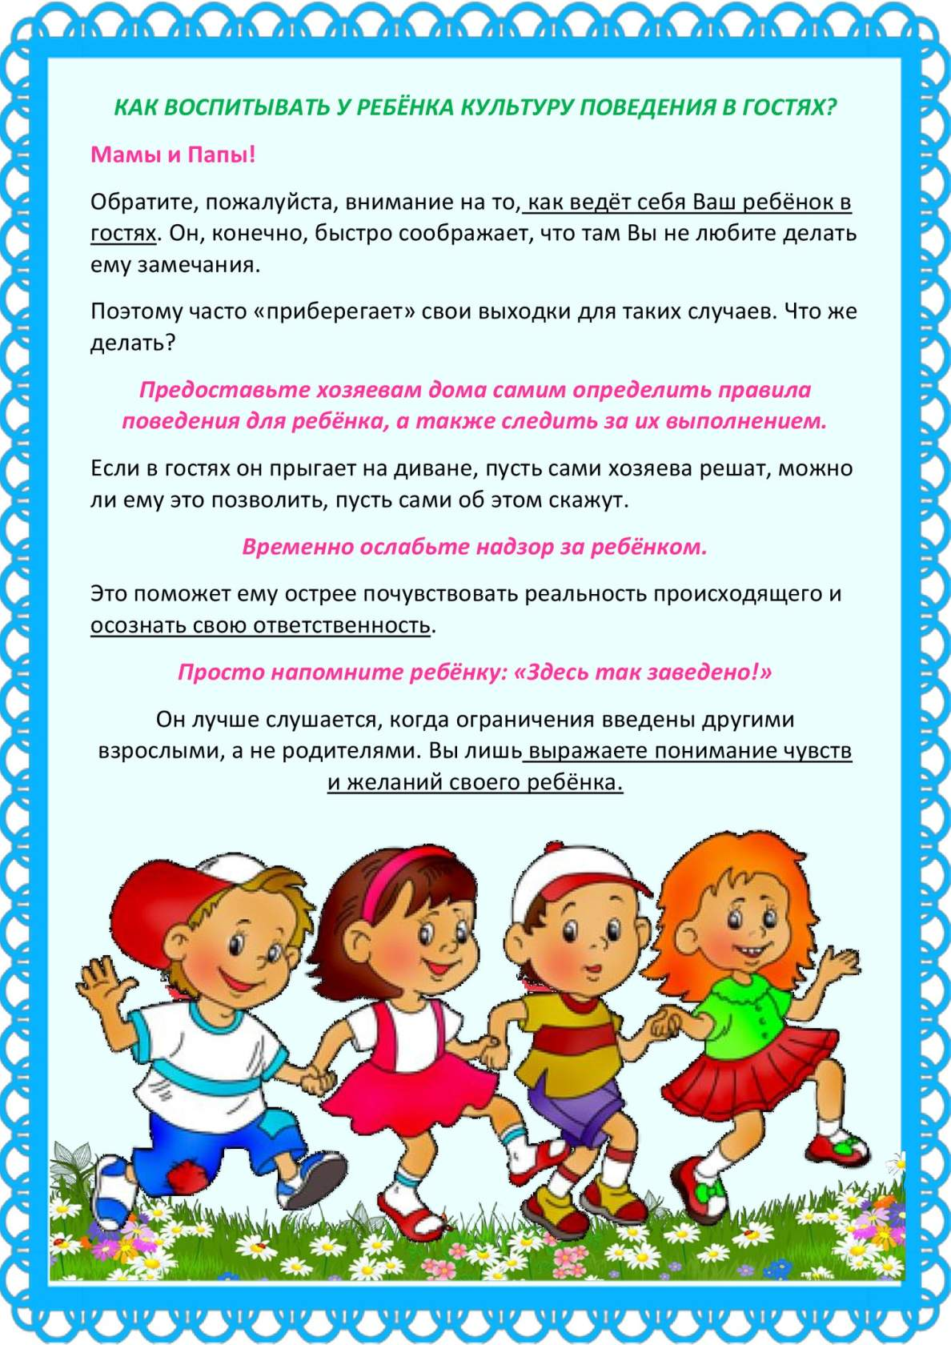](https://ok.ru/dk?cmd=PopLayerPhoto&st.layer.cmd=PopLayerPhotoOuter&st.layer.type=GROUP&st.layer.revNav=off&st.layer.limitedUi=false&st.layer.closeLayers=off&st.layer.sphotoIds=872274822496%3B872274827872%3B872274827360%3B872274827104%3B872274826848%3B872274826592%3B872274826336%3B872274826080%3B872274825824%3B872274825568%3B872274825312%3B872274825056%3B872274824800&st.layer.showNav=on&st.layer.photoAlbumId=53612444975200&st.layer.epm=off&st.layer.photoId=872274825568&st.layer.opl=off&st.layer.navStartPhotoId=872274825568&st.layer.sbd=off&st.cmd=userMain&st._aid=GroupTopicLayer_openPhotoLayer)

[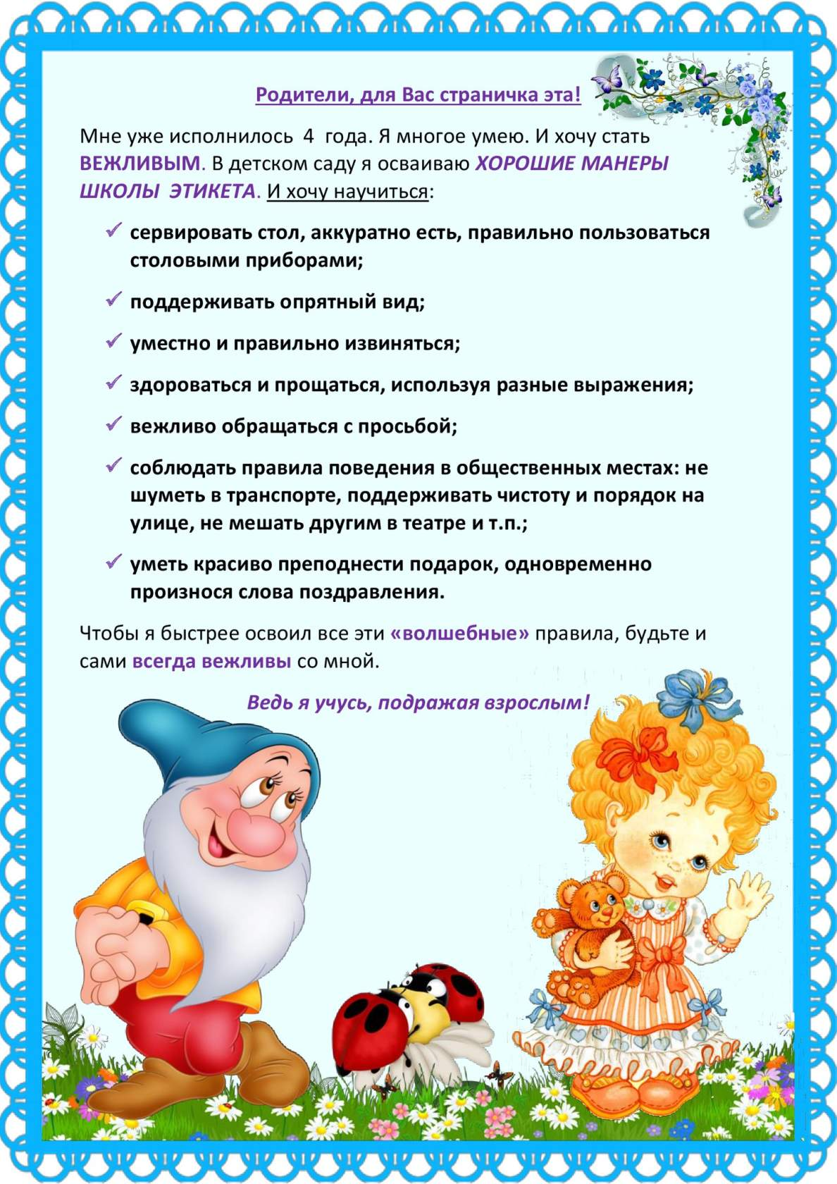](https://ok.ru/dk?cmd=PopLayerPhoto&st.layer.cmd=PopLayerPhotoOuter&st.layer.type=GROUP&st.layer.revNav=off&st.layer.limitedUi=false&st.layer.closeLayers=off&st.layer.sphotoIds=872274822496%3B872274827872%3B872274827360%3B872274827104%3B872274826848%3B872274826592%3B872274826336%3B872274826080%3B872274825824%3B872274825568%3B872274825312%3B872274825056%3B872274824800&st.layer.showNav=on&st.layer.photoAlbumId=53612444975200&st.layer.epm=off&st.layer.photoId=872274825312&st.layer.opl=off&st.layer.navStartPhotoId=872274825312&st.layer.sbd=off&st.cmd=userMain&st._aid=GroupTopicLayer_openPhotoLayer)

[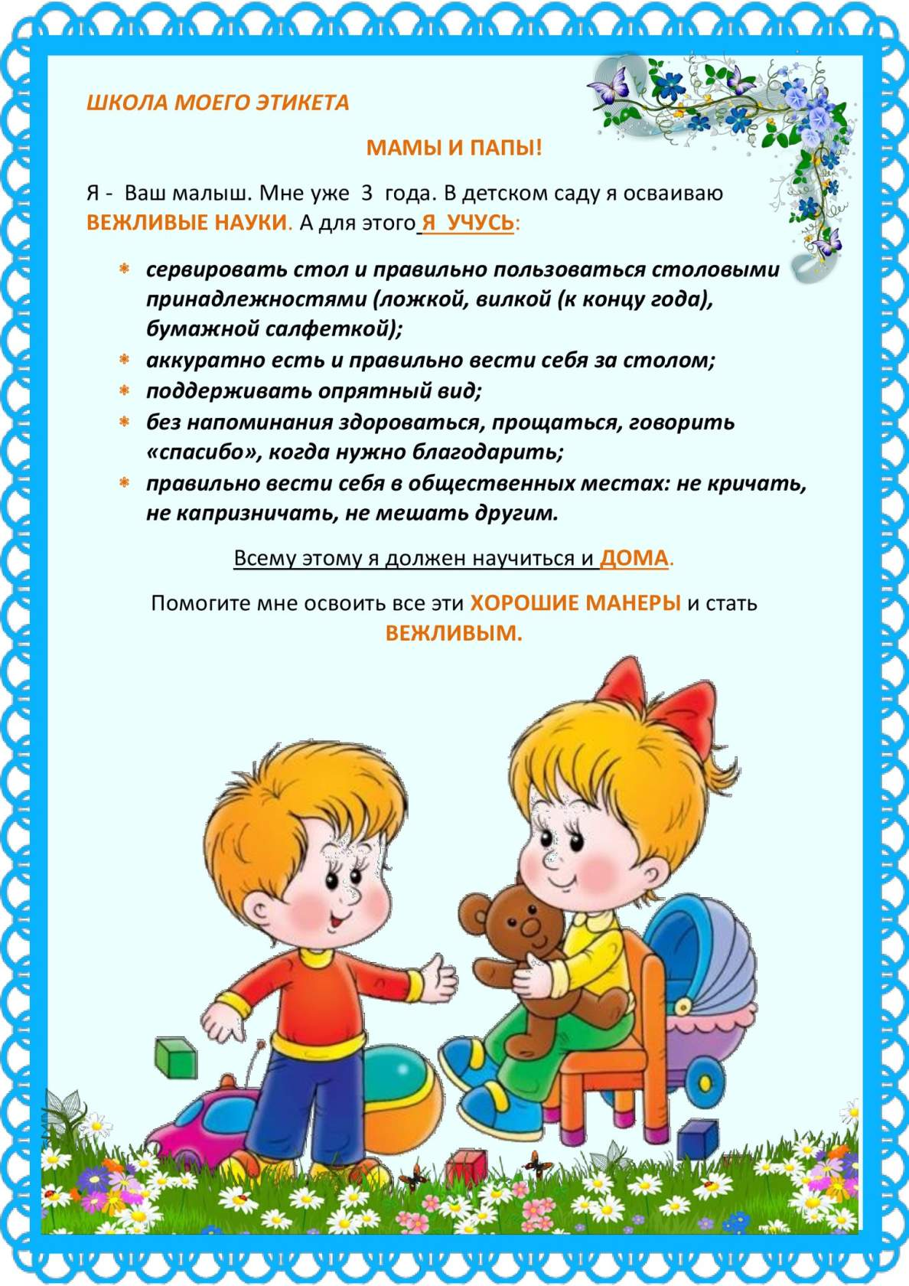](https://ok.ru/dk?cmd=PopLayerPhoto&st.layer.cmd=PopLayerPhotoOuter&st.layer.type=GROUP&st.layer.revNav=off&st.layer.limitedUi=false&st.layer.closeLayers=off&st.layer.sphotoIds=872274822496%3B872274827872%3B872274827360%3B872274827104%3B872274826848%3B872274826592%3B872274826336%3B872274826080%3B872274825824%3B872274825568%3B872274825312%3B872274825056%3B872274824800&st.layer.showNav=on&st.layer.photoAlbumId=53612444975200&st.layer.epm=off&st.layer.photoId=872274825056&st.layer.opl=off&st.layer.navStartPhotoId=872274825056&st.layer.sbd=off&st.cmd=userMain&st._aid=GroupTopicLayer_openPhotoLayer)

[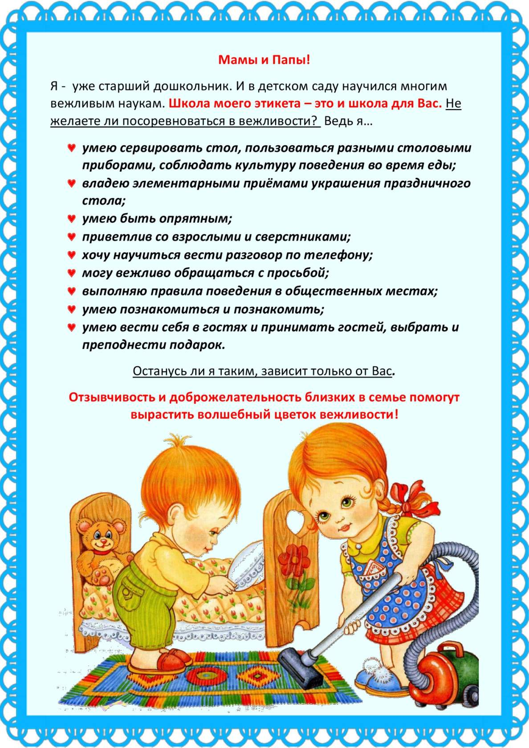](https://ok.ru/dk?cmd=PopLayerPhoto&st.layer.cmd=PopLayerPhotoOuter&st.layer.type=GROUP&st.layer.revNav=off&st.layer.limitedUi=false&st.layer.closeLayers=off&st.layer.sphotoIds=872274822496%3B872274827872%3B872274827360%3B872274827104%3B872274826848%3B872274826592%3B872274826336%3B872274826080%3B872274825824%3B872274825568%3B872274825312%3B872274825056%3B872274824800&st.layer.showNav=on&st.layer.photoAlbumId=53612444975200&st.layer.epm=off&st.layer.photoId=872274824800&st.layer.opl=off&st.layer.navStartPhotoId=872274824800&st.layer.sbd=off&st.cmd=userMain&st._aid=GroupTopicLayer_openPhotoLayer)